

**INDIVIDUAL ASSIGNMENT.**

**CT106-3-2-SNA.**

**SYSTEM NETWORK ADMINISTRATION.**

**HAND OUT DATE: 3RD WEEK.**

**HAND IN DATE: 11TH WEEK.**



INTAKE CODE: APD1F2309CS(CYB).

MODULE CODE: CT106-3-2- SNA.

STUDENT NAME: ABDULRAHMAN GAMIL . MOHAMMED AHMED.

TP-NUMBER: TP071012.

Contents

**1-** **INTRODUCTION.** 2

**2- Installation of VMware.** 3

**3-** **Installation of Ubuntu OS.** 4

**4-** **Installing and Configure DNS Server.** 10

**5-** **DHCP Server.** 15

**6-** **Email Server Using Postfix and Dovecot.** 19

**7-** **Web Server Using Apache2.** 24

**8-** **LDAP Server.** 27

**9-** **SSL and TLS Implementation.** 36

**10-** **Testing The System.** 43

**11-** **Conclusion.** 46

**12-** **References.** 47

1. **INTRODUCTION.**

In the changing world of information technology the success of an organization relies on having a strong and secure system, in place. This guide serves as your roadmap to building a Linux based system that is specifically designed to meet the unique needs of a compact enterprise. By utilizing Virtual Boxs capabilities we embark on a journey to create an environment running Linux Ubuntu. Our objective is to establish an seamless network through the systematic integration of essential services.

We begin by installing Virtual Box, which sets the foundation for creating a machine running Linux Ubuntu. This virtualized environment becomes our canvas as we progressively integrate services to build a system.

Our journey commences with setting up a Domain Name System (DNS) server using BIND on the machine. This crucial step ensures translation of human domain names into IP addresses enabling smooth navigation and communication within the network. Next we move on to configuring a Dynamic Host Configuration Protocol (DHCP) server optimizing the assignment of IP addresses and network parameters for client devices.

Expanding our focus towards communication and collaboration we. Configure an email server using Postfix and Dovecot. This enables email management empowering organizations to send and receive emails, with ease.

At the time setting up and configuring an Apache web server enables the machine to have an online presence meeting the organizations requirements, for web hosting.

In the field of identity and access management our guide delves into the process of setting up and configuring an LDAP server using OpenLDAP on a machine. This enables organizations to have a directory service making user authentication and access control simpler.

We give importance to security by implementing SSL/TLS encryption, for both email and web services on the machine. This ensures that data transmitted through these services remains confidential and intact strengthening the system against threats.

Lastly we verify the functionality of our integrated system to ensure that clients can effortlessly access the website send and receive emails and authenticate themselves using LDAP. This comprehensive approach to designing Linux infrastructure results in a secure and efficient system designed specifically for the needs of organizations. It sets the stage, for connectivity and collaboration opportunities.

1. **Installation of VMware.**

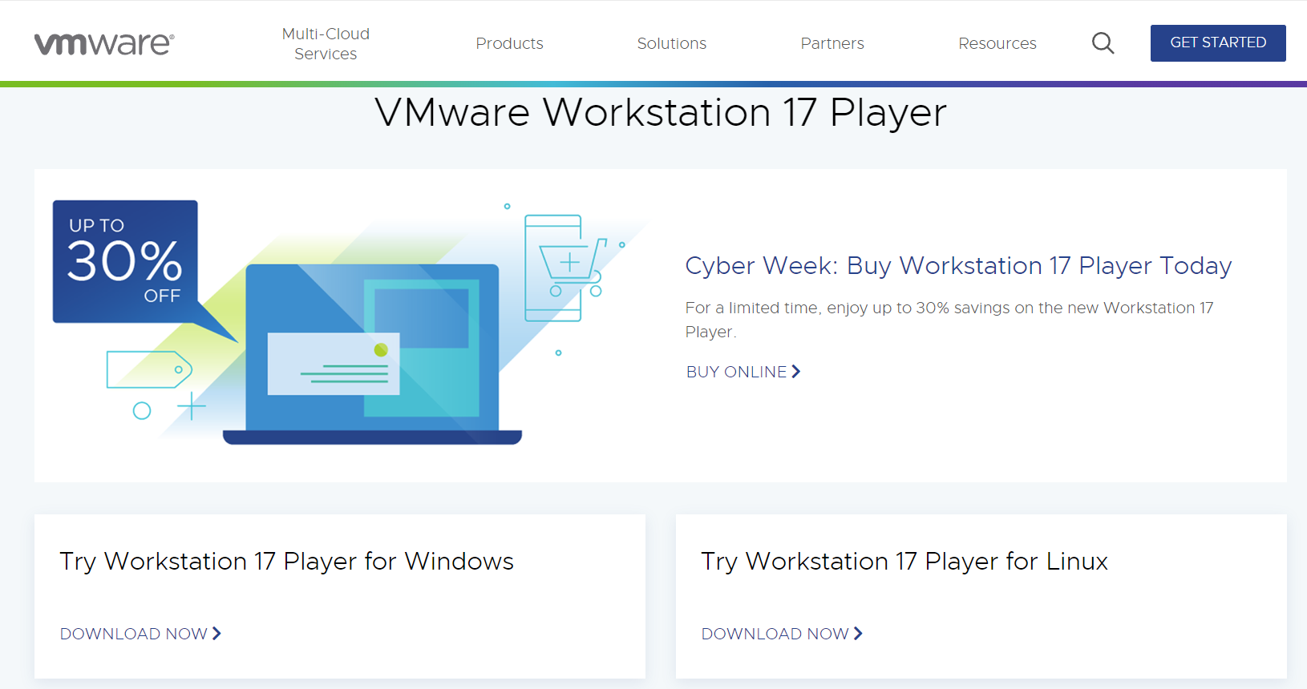

Figure 1

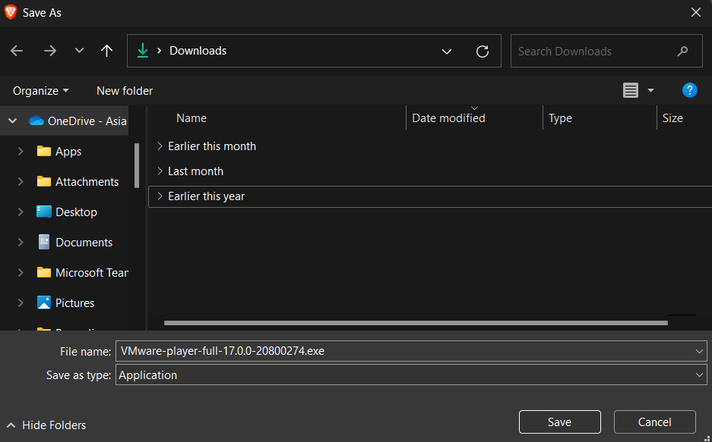

Figure 2

VMware Workstation 17 Player allows users to easily create and manage environments within their existing operating system. This feature enables users to simulate computing setups, which proves beneficial, for tasks like software testing, development and experimenting with operating systems. The next step involves selecting and installing a guest operating system that functions within the machine. It provides a space for exploring computing experiences without affecting the host system. The choice of guest operating system depends on the users requirements, such as opting for Linux distributions like Ubuntu for development purposes or ensuring compatibility, with applications by choosing Windows.

1. **Installation of Ubuntu OS.**

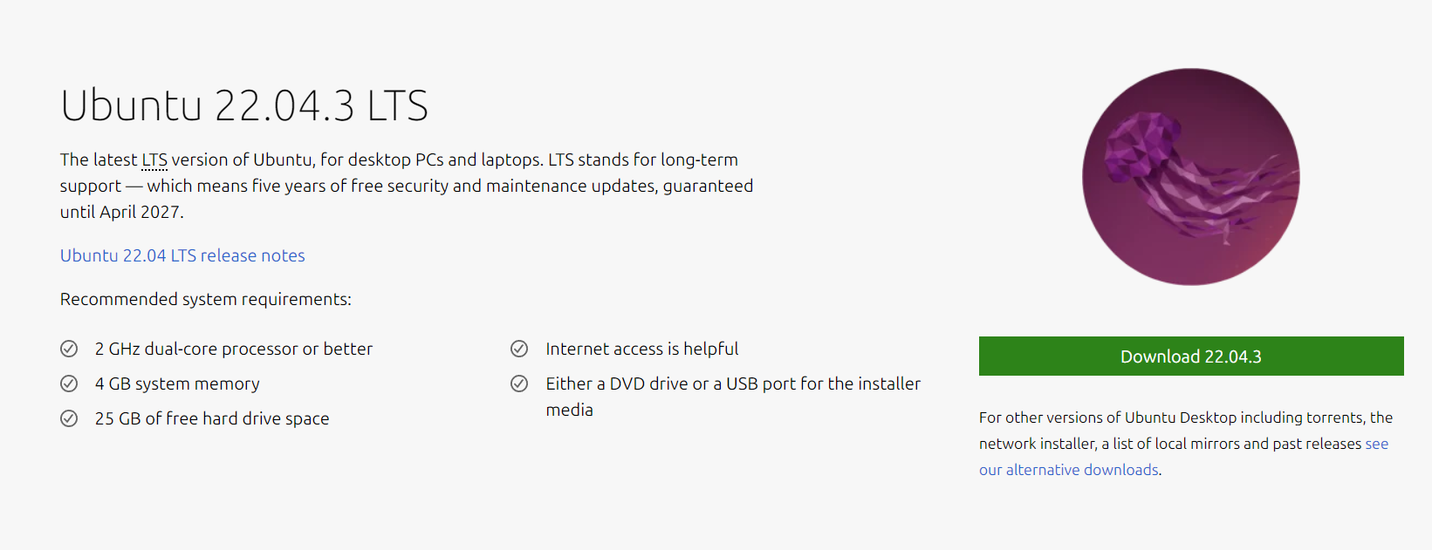

Figure 3

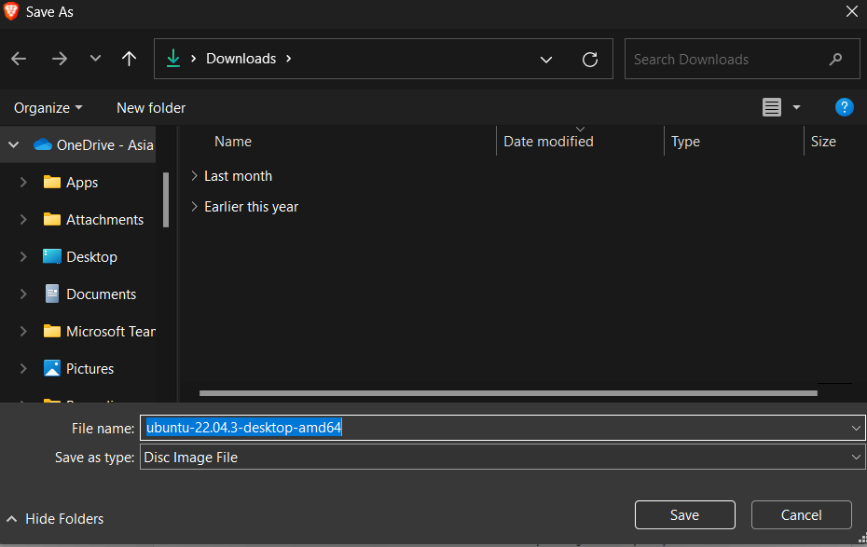

Figure 4

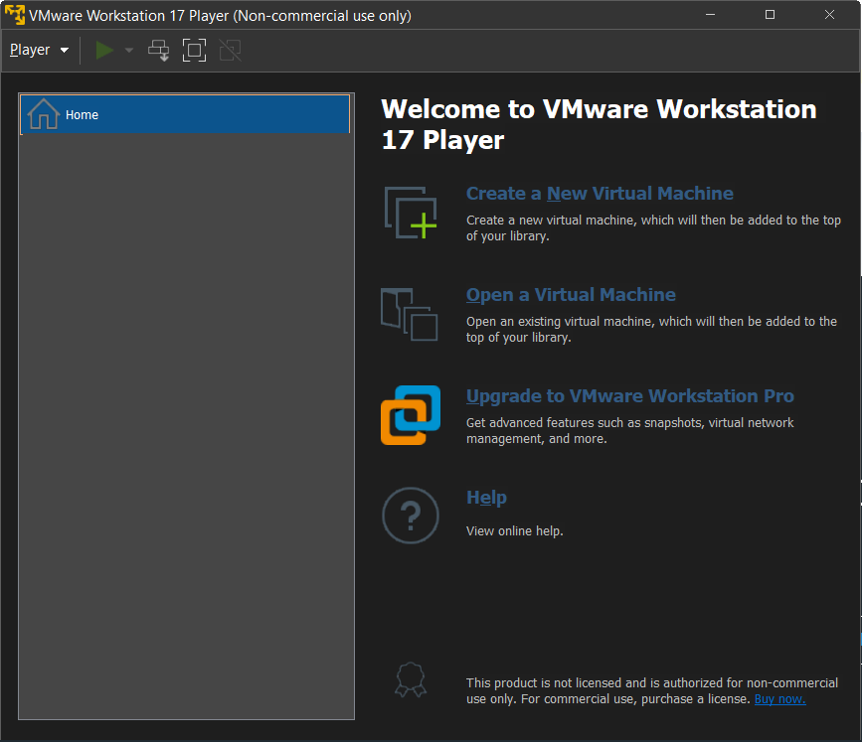

Figure 5

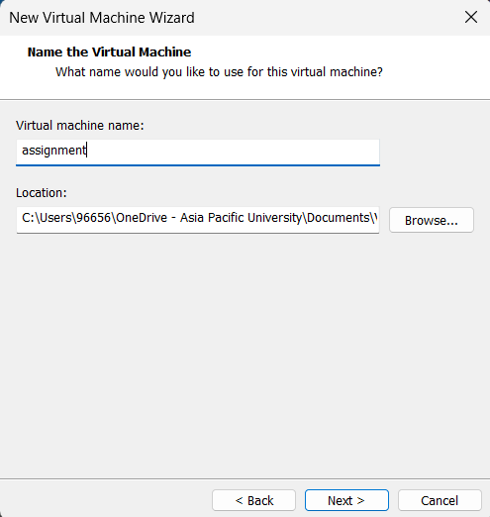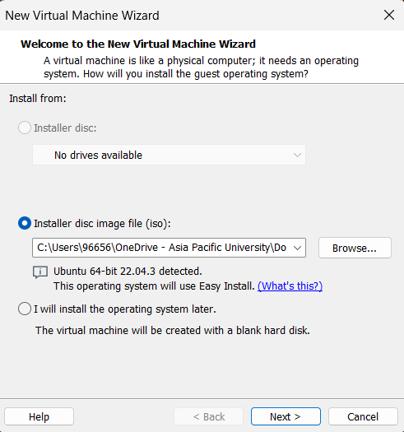

Figure 6

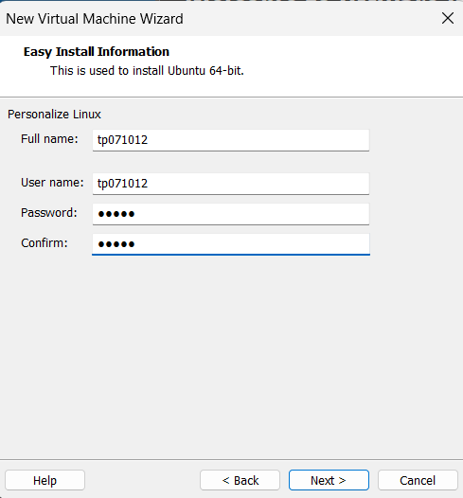

Figure 7

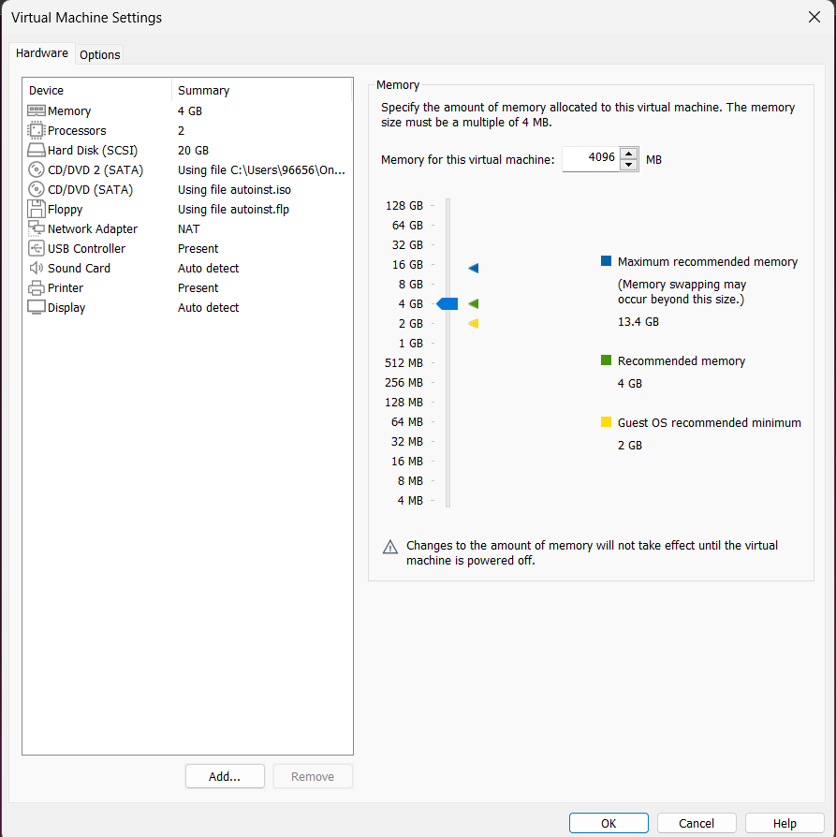

Figure 8



Figure 9

After installing Ubuntu in the machine (VM) the next step is to configure the guest operating system, for specific purposes. This involves customizing and setting up server roles, such as DNS, DHCP, a web server (like Apache or Nginx) an email server (using Postfix) and LDAP for directory services.

To create an isolated environment within your existing operating system you can install Ubuntu Desktop in a VMware machine. Start by downloading and installing the version of VMware Workstation Player from the VMware website. Once installed obtain the Ubuntu Desktop ISO file from the Ubuntu website. With both software components ready VMware Workstation Player. Create a new virtual machine.

Select "Installer disc image file (iso)" as the installation option. Choose the downloaded Ubuntu ISO file. Specify the guest operating system as "Linux" with the version set to "Ubuntu."

Provide a name for your machine. Choose a location for its storage. Determine the disk capacity typically recommended at 25 30 GB and optionally customize hardware settings, like RAM allocation (it is advisable to allocate 2 GB). Once you have configured these settings for your machine you can begin with the installation process.

When you are installing Ubuntu make sure to follow the prompts, for setting up the language, time zone, keyboard layout and creating a user account.

Do the first thing after the installation is to write the folloing commands in terminal "sudo apt update" command updates the package list and collects the most recent information about package availability. Once the new packages are installed, "sudo apt upgrade" ensures that your system receives the most recent security updates and enhancements. Maintaining the security and updates of your Linux system depends on these two commands.

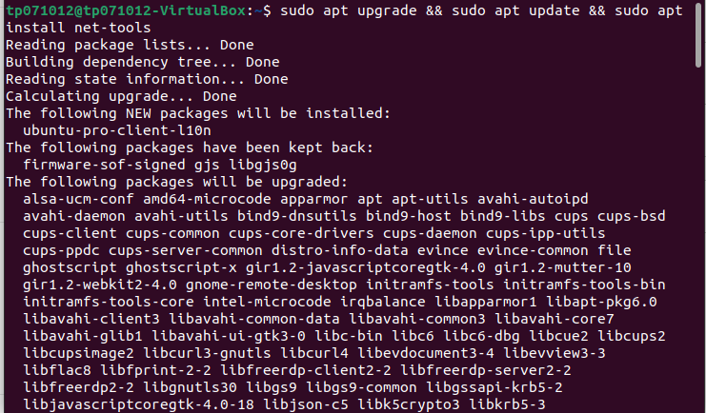

Figure 10

In the above screenshot it is clear that the system installing all the packages that will be needed by the virtual machine, also to help us to config the servers for the company to enhance the company’s communcation.

1. **Installing and Configure DNS Server.**

DNS, which stands for Domain Name System, is the internet's address converter. It translates human-readable domain names into machine-readable IP addresses, enabling smooth web navigation. DNS, in essence, guarantees that when we type in a web address, it immediately sends us to the proper website by converting it to the associated IP address. Because this crucial service is at the centre of practically every online contact, it is a critical component of the digital infrastructure. As we go deeper into networking and system integration, understanding the role of DNS becomes crucial, as it is the quiet facilitator of efficient and dependable communication in the online world (Internet Systems Consortium, 2020).

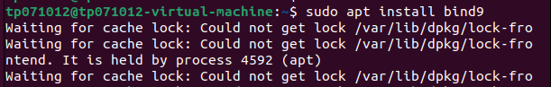

Figure 10

The above command installs bind9 packages that're responsible, for managing DNS configuration files. These files determine how the DNS server processes queries and translates domain names into IP addresses. Having an understanding of these packages is essential, for customizing DNS settings according to requirements. They serve as the building blocks of a DNS system enabling administrators to adjust configurations for optimal performance. By executing this command you can start utilizing the features of bind9. Create a personalized and refined DNS environment.



Figure 11

To modify BINDs configuration file you can use the command "sudo nano ‎/etc/bind/named/named.conf.options". This command grants administrators access to named.conf.options, which is located in /etc/bind/named/. It allows you to make modifications to DNS settings. Within this file you can customize options such, as forwarding, logging and global parameters. This hands on approach gives you the ability to fine tune your DNS server, for performance.

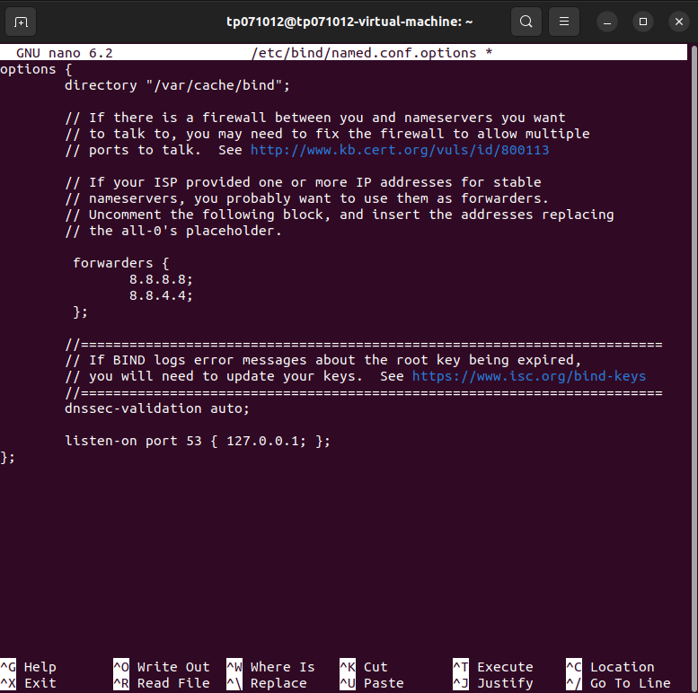

Figure 12

To open the named.conf.options file, for editing you can use the "sudo nano" command. This file is crucial as it allows DNS forwarding and optimal configuration using Google DNS server IP addresses (8.8.8.8 and 8.8.4.4). In the configuration we specify the listen on port 53 with the loopback address (127.0.0.1) to ensure that the DNS server accepts queries on this port. This meticulous configuration enables administrators to define how BIND handles DNS queries and forwarding ultimately improving server efficiency. The attention to detail in configuring DNS is evident, in each aspect of named.conf.options.



Figure 13

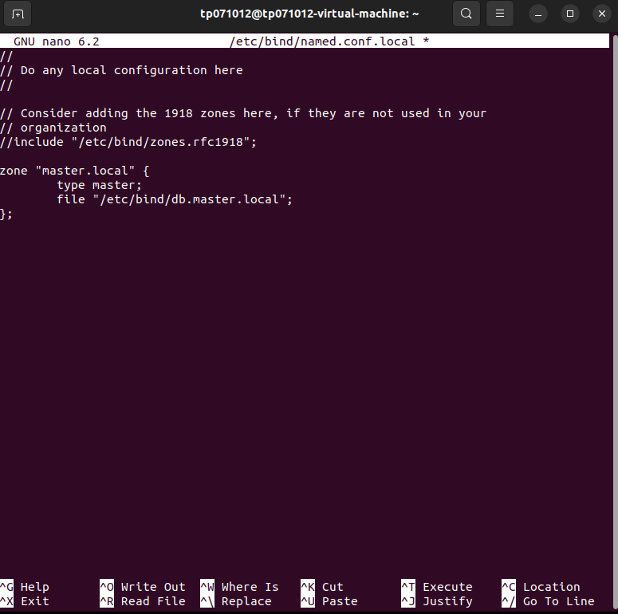

Figure 14

To continue you can use the command "sudo nano /etc/bind/named.conf.local" to open the configuration file, for BIND that's specific to your settings. This step is crucial as it allows you to create a master zone called db.master.local which will be located in the /etc/bind directory. The named.conf.local file acts as a gateway for defining DNS zones enabling administrators to configure settings that are specific to each zone and link them with their corresponding zone data files. This process ensures that BIND operates in an structured manner facilitating management of domain information while enhancing the DNS servers ability to accurately resolve queries, for the designated master zone.



Figure 15

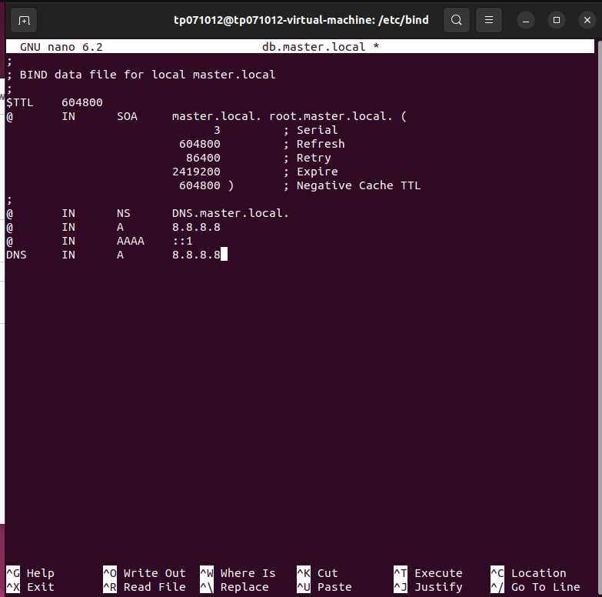

Figure 16

After executing the instruction shown in Figure 15 we proceed to open the generated file in order to shape the configuration framework. In this step we define DNS records, within the file that align with the requirements of the master zone. It is worth noting that the naming convention of these records reflects the file name itself which promotes clarity and organization. By populating with details such as resource records, IP addresses and hostnames administrators establish a solid foundation for a precise and responsive DNS resolution process. This meticulous configuration, within the zone file ensures that the DNS server can effectively translate domain names into their IP addresses within the designated zone.

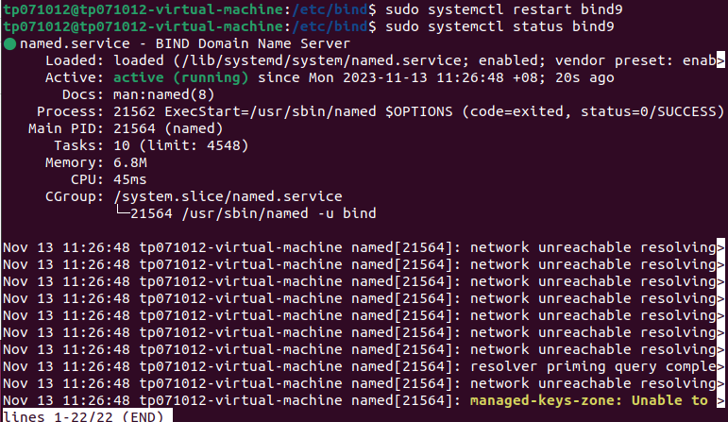

Figure 18

To restart the server and apply configuration changes it is important to use the command "sudo systemctl restart bind9." You can check the real time status of the server using "sudo systemctl status bind9" command. This will help you confirm if the server is running smoothly or if there are any issues that need to be addressed. By following this approach administrators can make modifications seamlessly. Promptly address any potential problems ensuring the reliability and responsiveness of the DNS server.

1. **DHCP Server.**

In the realm of networking, the Dynamic Host Configuration Protocol (DHCP) server is a covert facilitator that facilitates the process of connecting devices to networks. DHCP serves as an automated setup manager when a device joins the network, dynamically assigning IP addresses and other network features to it. Consequently, the need for manual setup has been eliminated, greatly simplifying the onboarding procedure. Subnet masks, default gateways, and DNS server addresses are additional information that DHCP may supply in addition to IP addresses to ensure that devices are connected and configured properly for optimal network connectivity. In summary, DHCP facilitates network administration, boosts scalability, and maintains the flexibility of existing network topologies (Gillis, 2023).

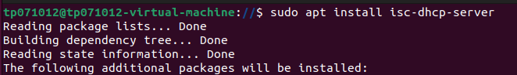

Figure 19

Figure 19 shows how to install DHCP packages using the "sudo apt install isc-dhcp-server" command. This straightforward method allows for network-wide automated IP address assignments by integrating the ISC DHCP server. This phase increases efficiency and scalability by simplifying the network design.



Figure 20

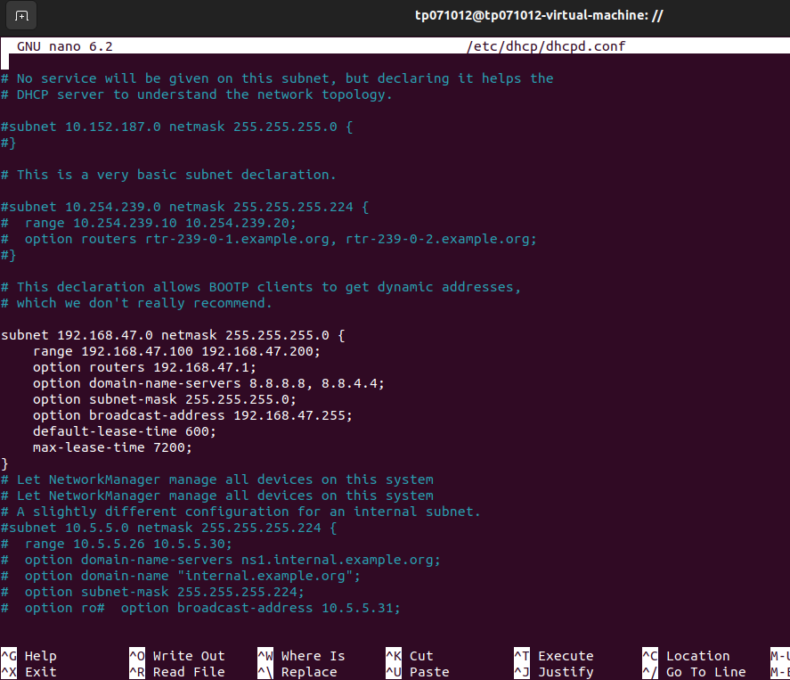

Figure 21

We investigate the DHCP configuration seen in Screenshots 20 and 21 by executing "sudo nano /etc/dhcp/dhcpd.conf." This file defines the critical parameters that govern the assignment of IP addresses. The additional lines added to the subnet block (subnet 192.168.47.0 netmask 255.255.255.0) specify the address range (192.168.47.100 to 192.168.47.200), default gateway (192.168.47.1), DNS servers (8.8.8.8, 8.8.4.4), subnet mask, broadcast address, default lease time (600 seconds), and maximum lease time (7200 seconds). This change ensures that devices connected to the 192.168.47.0 network dynamically obtain the appropriate settings by customising the behaviour of the DHCP server. The numerous factors that determine how IP addresses are allocated and managed by the DHCP server highlight how complicated it is to set up DHCP for efficient network administration.



Figure 22

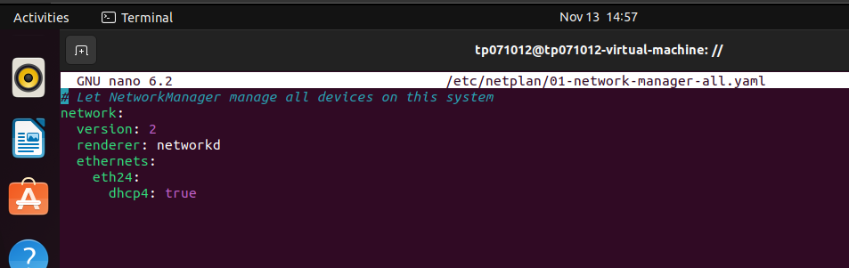

Figure 23



Figure 24

Figures 22, 23, and 24 demonstrate how to use “sudo nano” to examine the 01-network-manager-all.yaml file directly and access the /etc/netplan directory. In this file, we modify the network configuration, specifically permitting DHCP (dhcp4: true) for the ‘eth24’ interface. We may ensure that the machine connects to the DHCP server that we previously configured by doing this action. Figure 24 shows the updated network settings after running “sudo netplan apply.” This process highlights how important it is to adjust network configurations to stay current with DHCP updates. This will ensure proper IP address distribution and seamless network connectivity.



Figure 25

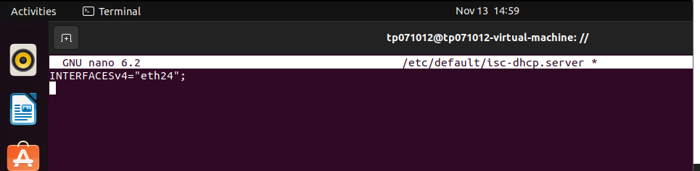

Figure 26

Using “sudo nano” to access “/etc/default/isc-dhcp-server” and configure the server interface is demonstrated in Figure 25. The interface “eth24” is added to the file in Figure 26 after editing it and saving it. This process ensures that the server connects with the specified network effectively by identifying the ISC DHCP server’s unique interface. By setting the server to match a particular interface, we maximise the functionality of DHCP and enable the precise and targeted management of IP address distributions throughout the network.

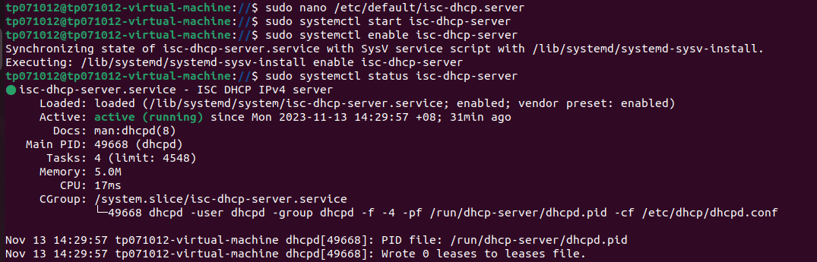

Figure 27

Start the ISC DHCP server with “sudo systemctl start isc-dhcp-server,” enable it with “sudo systemctl enable isc-dhcp-server,” and verify its status with “sudo systemctl status isc-dhcp-server.” This guarantees that the server is up and running and that dynamic IP configurations are available inside the assigned network.

1. **Email Server Using Postfix and Dovecot.**

Dovecot and Postfix are the main components of email infrastructure. Emails are efficiently routed and sent using a mail transfer agent called Postfix, ensuring consistent message delivery. Dovecot is an IMAP and POP3 server that facilitates secure email retrieval and inbox management for users. Dovecot and Postfix are a strong pair because they collaborate to handle the sending and receiving ends of email interaction. Businesses may create up secure, scalable, and efficient email services using its integration. It makes this all-inclusive email solution feasible (Why, 2015).

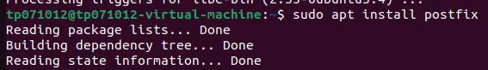

Figure 28

To install Postfix mail server, run “sudo apt install postfix” as shown in Figure 28. Ensuring the system’s ability to manage email services is a crucial initial step in developing a comprehensive network design, and this command provides such assurance.

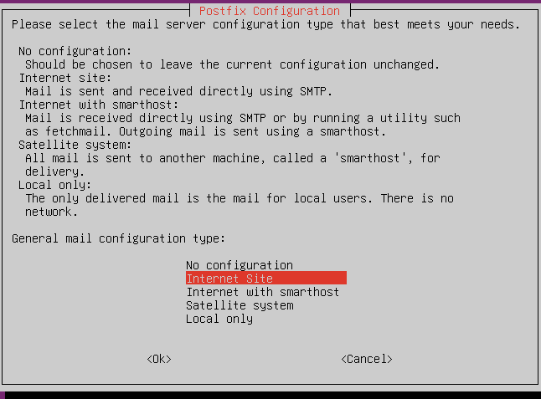

Figure 29

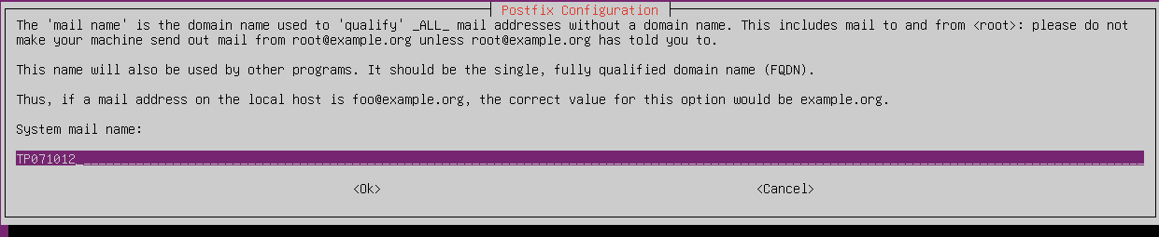

Figure 30

Figures 29 and 30 depict the Postfix installation procedure with the mail server set up for optimal performance. The pink page, an interactive setup tool, guides users through key configuration settings such mail server type and system mail name. This straightforward setup ensures a tailored installation, which is essential to the smooth operation of the network’s email services.



Figure 31

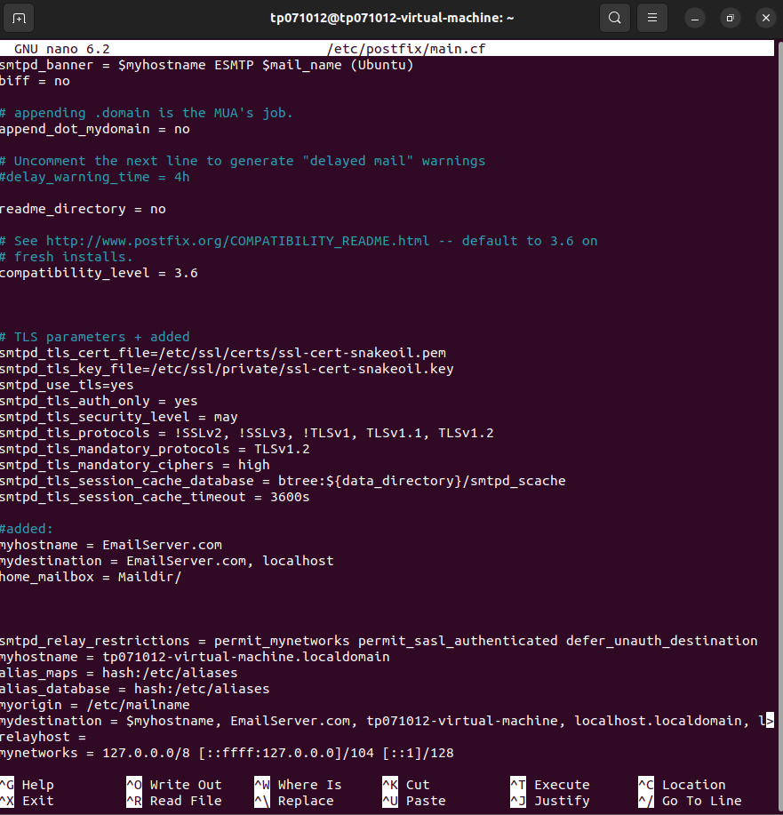

Figure 32

Figures 31 and 32 show the Postfix configuration file that may be accessed by running “sudo nano /etc/postfix/main.cf”. “myhostname = EmailServer.com,” “mydestination = EmailServer.com, localhost,” and “home_mailbox = Maildir/” can be added to modify Postfix settings. Because of this change, the mail server can store messages in the Maildir format, identify its hostname, and effectively handle local delivery. These parameters improve Postfix for the specified domain and promote effective system email handling; they are directly modified in main.cf.



Figure 33

To install the Dovecot IMAP and POP3 protocols, type “sudo apt install dovecot-imapd dovecot-pop3d” as shown in Figure 33. With the use of this command, Dovecot’s capability may be expanded to provide the network with flexible and safe email access options.

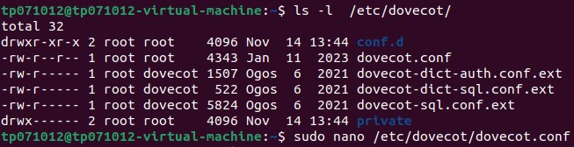

Figure 34

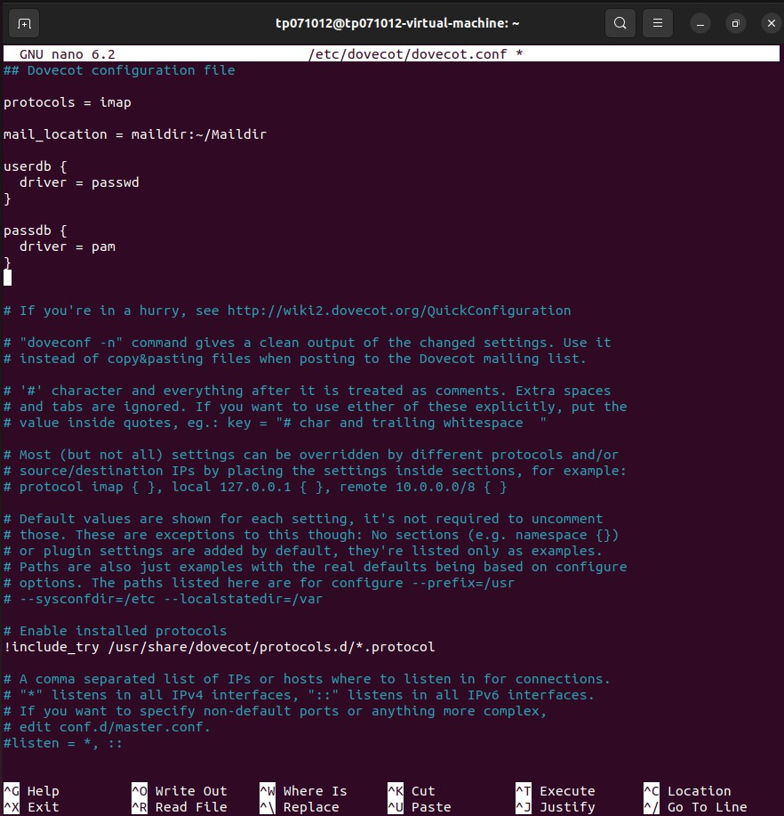

Figure 35

As seen in Figure 34, “sudo nano /etc/dovecot/dovecot.conf” may be used to access the Dovecot configuration file. Figure 35 shows the addition of necessary text connecting Dovecot to Postfix. This change sets up “mail_location,” “protocols = imap,” and user authentication settings to synchronise Dovecot with Postfix. This makes it simple to get and store emails in the designated Maildir format. These configurations ensure that Dovecot integrates securely and efficiently with the architecture of the email server, enabling a cohesive and efficient email management system throughout the network.

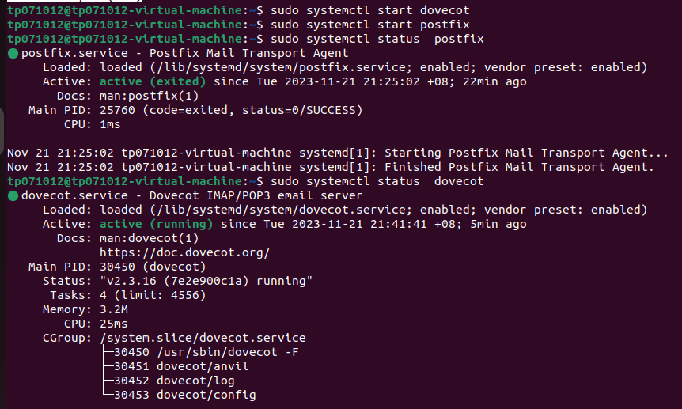

Figure 36

Postfix and Dovecot are both turned on at the same time, as Figure 36 illustrates. This demonstrates that both email services are operating within the network and have been effectively integrated. When the email server is in the “active (running)” state, administrators may relax knowing that every part of it is operational. A robust and flexible email system is the outcome of Postfix and Dovecot’s successful integration, highlighting the significance of these fundamental components for efficient email administration and exchange inside the network. The active status of an email system indicates reliability and functionality.

1. **Web Server Using Apache2.**

Apache2, the popular web server programme that replaces the Apache HTTP Server, is a powerful and adaptable tool. An open-source application with a large global user base, Apache2 is renowned for its dependability and effectiveness. It provides information interpretation and delivery across several computer languages, serving as the backbone for numerous websites. Due to its modular nature, Apache2 may be readily adjusted to fit the specific needs of administrators by integrating with a wide range of modules and extensions. The reason Apache2 has been a stalwart in the internet hosting and server deployment industry is its scalability, adaptability, and longevity (Syed Balkhi, 2013).

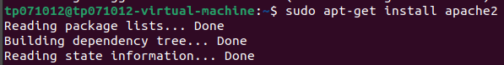

Figure 37

"sudo apt-get install apache2” must be executed in order to install Apache2. This programme quickly configures Apache2 and gets it ready for your system’s use in web hosting, content serving, and dynamic content management.



Figure 38

Use “sudo nano /var/www/html/index.html” in the Nano editor to open the default web page. By enabling you to rganizatio the content that shows when visitors reach your Apache2 web server, this file simplifies the process of configuring the first website.

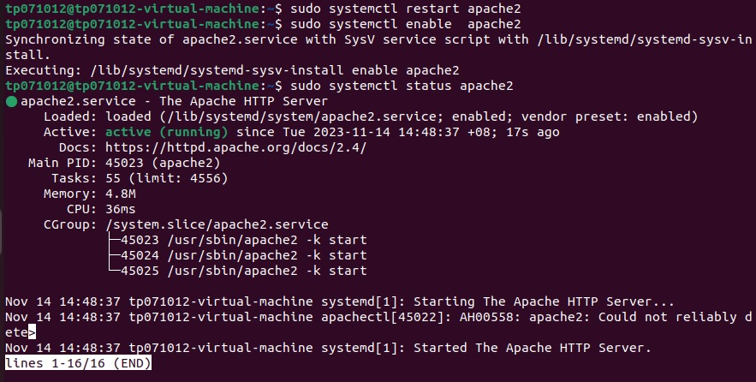

Figure 39

Any changes made to Apache2’s configuration are applied when you restart it using the command “sudo systemctl restart apache2”. You may find out the most recent status of Apache2 by running “sudo systemctl status apache2”. This will show you if Apache2 is having issues or is running properly. These commands ensure seamless operation and furnish details on the present state of the Apache2 web server.



Figure 40

The user and group "www-data" now has ownership of the "/var/www/html" directory thanks to the command "sudo chown www-data:www-data /var/www/html." Making sure that the right permissions are in place for file serving is a standard procedure for web servers. To execute the command, use the higher privileges granted by "sudo".

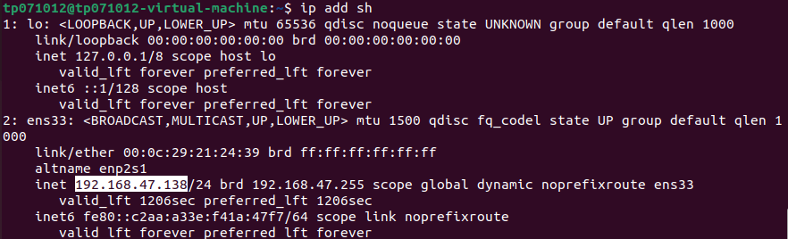

Figure 40

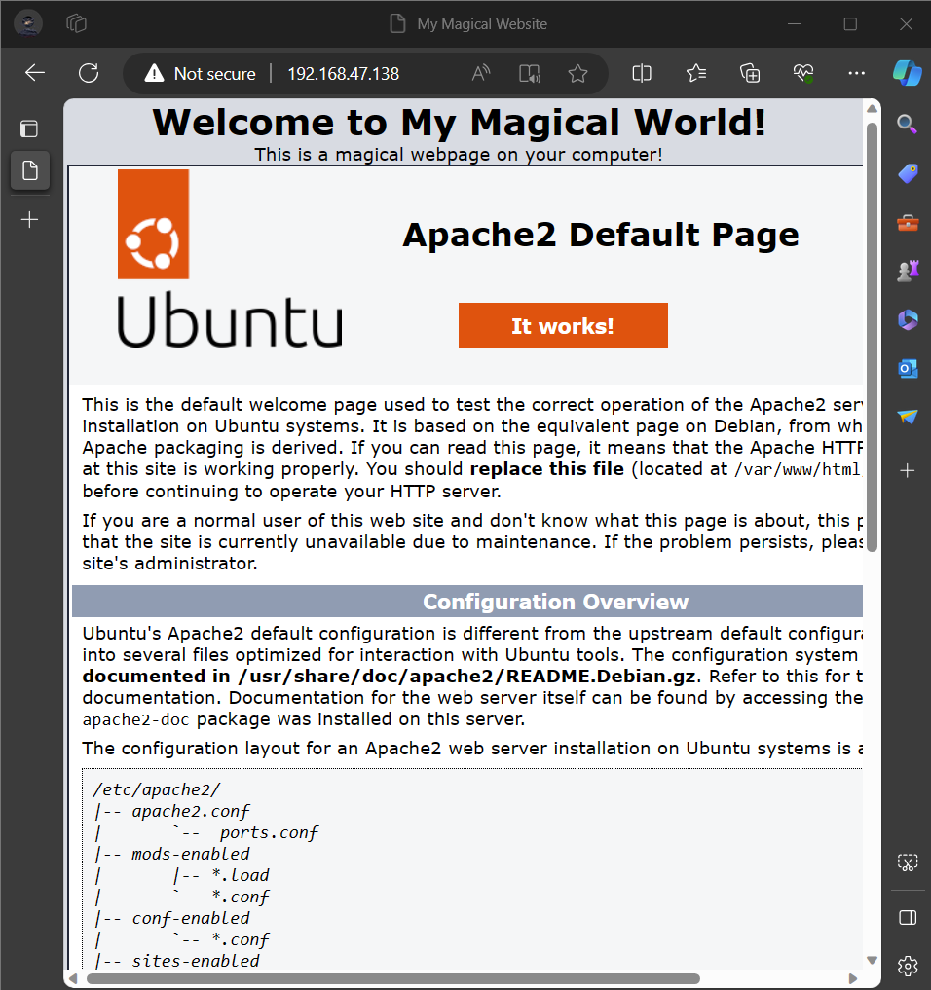

Figure 41

As shown in figure 40 that the network interfaces’ IP addresses are shown with the command “Ip add sh”. And also it is clear that in screenshot number 41 that the Apache2 web server may be contacted by visiting “http://192.168.47.138” on the internet using the provided IP address. With this direct IP access, users may see hosted content; the working website powered by Apache2 can be viewed at the provided URL.

1. **LDAP Server.**

Directory information services are managed and accessed via the Lightweight Directory Access Protocol (LDAP), a standard protocol. By providing a framework for information arrangement and access inside a directory, it enables rganizatio management of user identities, access limitations, and other attributes in a networked setting. A lot of people use LDAP for permission, authentication, and directory services. It offers businesses a scalable and efficient method for storing and retrieving data on users, devices, and network resources. The versatility and portability of LDAP make it an essential part of identity and access management system (*Okta, Inc.*, 2023).

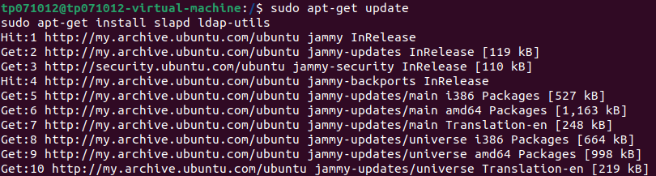

Figure 42

The package listings on the system can be updated and refreshed using the sudo apt-get update command. To install the LDAP packages after the update, type sudo apt-get install slapd ldap-utils. Since it builds the foundation for a modern and secure LDAP service, installing the most latest versions of the LDAP server and tools is crucial.

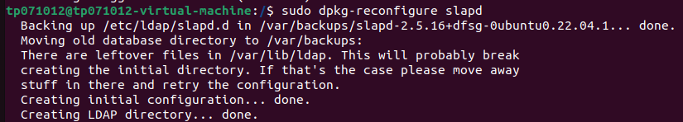

Figure 43

To precisely modify OpenLDAP settings for unique rganizational requirements, use “sudo dpkg-reconfigure slapd” to launch a configuration dialogue.

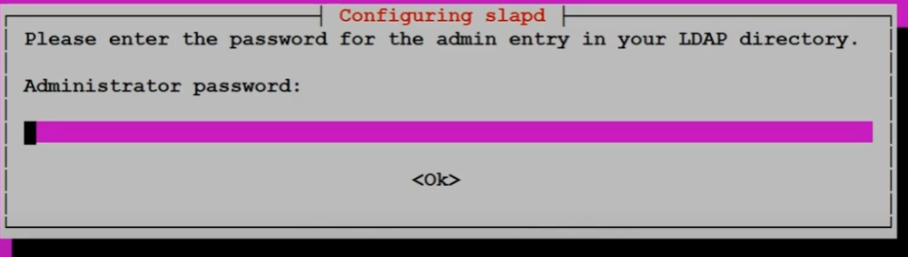

Figure 44

Setting the administrator password is one crucial security measure. LDAP entries may be handled and controlled thanks to the password’s privileged access to the LDAP directory. The integrity of the directory services depends on the strength and secrecy of this password.​

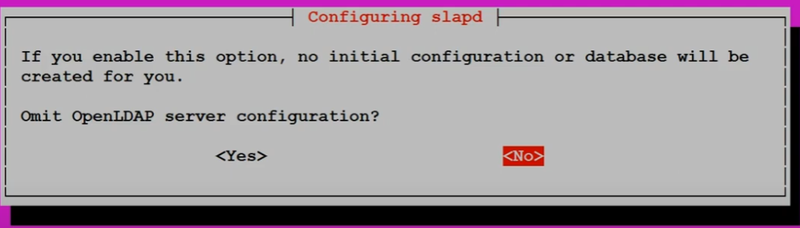

Figure 45

The first time you set up Slapd, a prompt appears asking whether you want to skip the OpenLDAP server configuration. Making this choice will determine how rganization the LDAP server will be. If “No” is selected, a comprehensive setup process is carried out.​

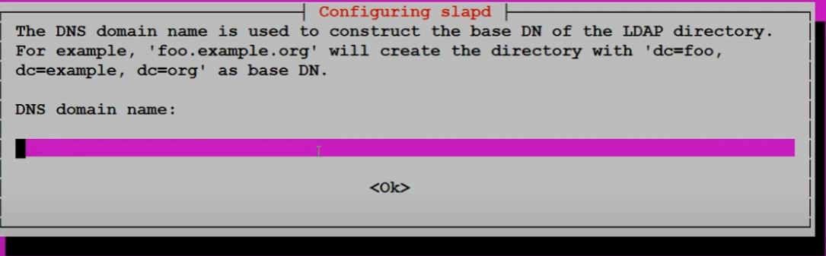

Figure 46

A popup requests the DNS domain name in order to construct the base Distinguished Name (DN) for the LDAP directory structure. The information entered here establishes the top-level domain component, which is the root of the directory tree in the LDAP hierarchy.​

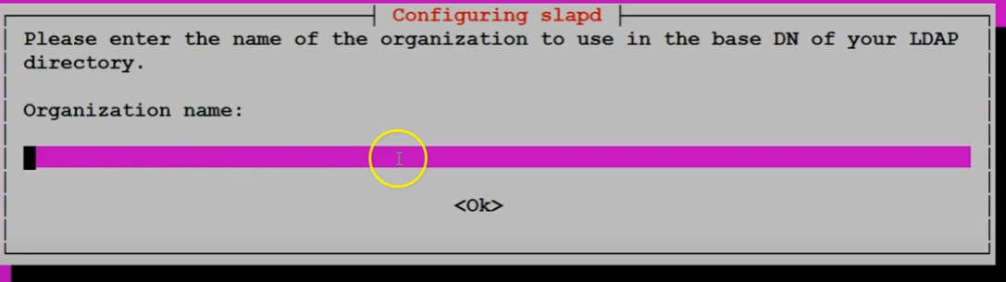

Figure 47

Through a configuration interface, the organization’s name is asked to be used in the LDAP directory’s base DN. The rganization name is an essential identifier in the LDAP directory tree, designating the rganizational unit under which each entry will be rganizatio.​

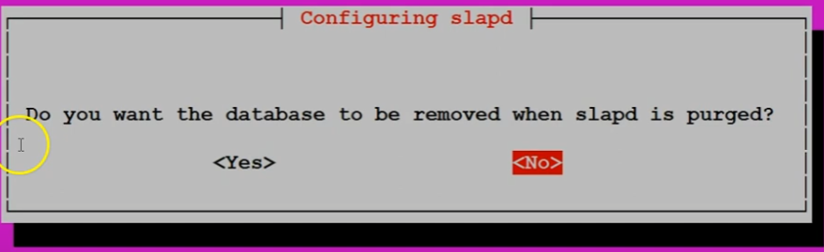

Figure 48

When the slapd software is uninstalled from the system, an option to delete the LDAP database appears in the dialogue box. This step is important for data retention requirements since selecting “Yes” will erase all directory data upon package removal—which may be necessary for a full cleansing or security reasons.​

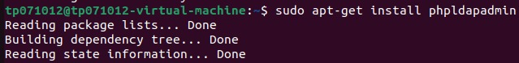

Figure 49

To install `phpLDAPadmin, type {sudo apt-get install phpldapadmin}. One of the configuration files in {/etc/phpldapadmin/} is `config.php}. It requires a web server and may be seen using a browser. During the first configuration, LDAP server information has to be given. It's essential to use strong passwords and take other security measures. Examining logs is one part of troubleshooting too. Verify that PHP is running well and that the web server is detected. especially if it's secure access that faces the internet. Adjust the configuration in accordance with your LDAP server's requirements. Examine and follow recommended practices often to improve security. Consult the handbook for further instructions and take care of any special server needs.

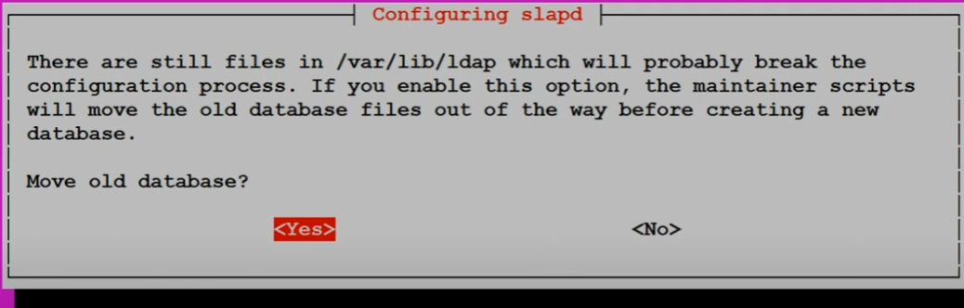

Figure 50

An important decision is made regarding the present files in the /var/lib/ldap directory. The maintenance scripts have the ability to relocate outdated database files in order to prevent problems with the upgraded LDAP setup. This step is crucial to maintaining a clean setup and preventing database corruption.​



Figure 51

Using the nano text editor, the ldap-data.ldif file modification process is shown on the terminal. A thorough edit of the LDIF file defining LDAP directory entries is required to ensure that the entries are structured correctly in compliance with LDAP standards.

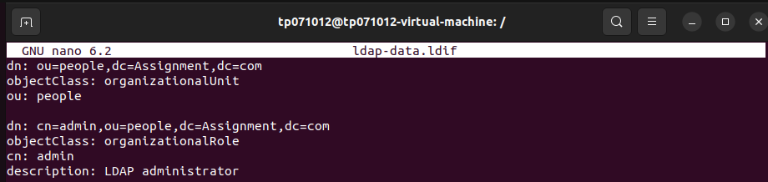

Figure 52

The LDIF file that was opened in the nano editor contains the LDAP entries that must be added. It clarifies the definitions of an rganizational unit and an administrative position inside the LDAP directory, which are essential building blocks for creating the directory’s structure.​

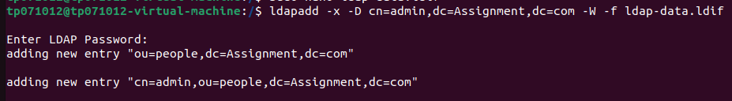

Figure 53

This records how new things are added to the LDAP directory. Using the ldapadd command to add the new data from the LDIF file, new rganizational units and roles are added to the LDAP directory.​

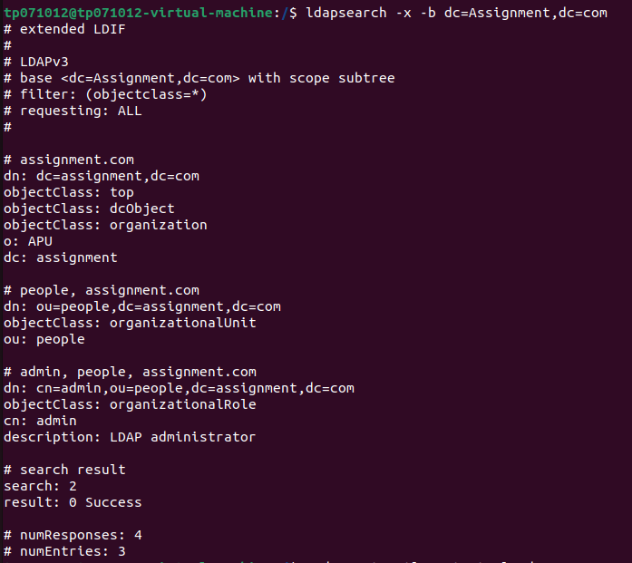

Figure 54

The results of an LDAP search operation are displayed, indicating that the directory query was answered successfully. By verifying the directory structure and presenting the base DN, administrative entries, and rganizational units, the outcome verifies the configuration changes that were made.​

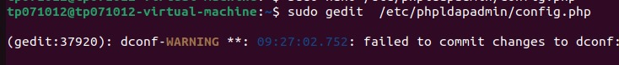

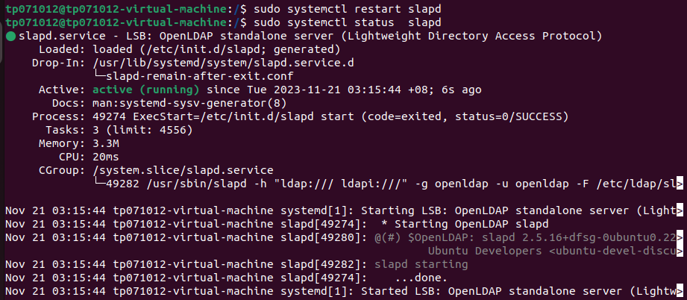

Figure 55

The system service manager, systemctl, may be used to verify the status of the slapd service. The terminal output indicates that the service was started or restarted successfully after setup, confirming that the LDAP service is operational. This final step is crucial to ensuring the LDAP service is operational and usable.​

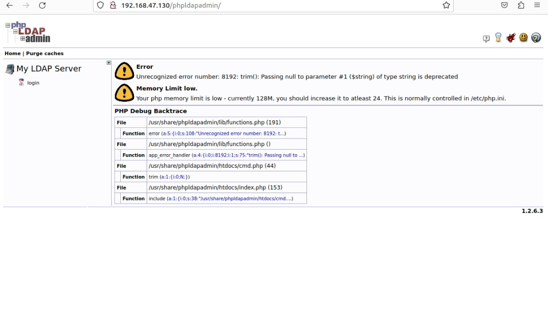

Figure 56

The image above figure 56 displays the online interface for phpLDAPadmin, a tool that allows LDAP servers to be controlled via a web browser. This interface is marked as for reference and prominently displays an error warning suggesting a low memory limit issue and deprecated coding method. While there is an error suggesting "24," the PHP memory limit is currently set at 128MB; it is advised to increase it to at least 24M. Additionally, there is a deprecation warning cautioning against using a null value when calling the `trim()` function. This error stack traces back across several PHP files to the precise code point where the issues occurred.



Figure 57

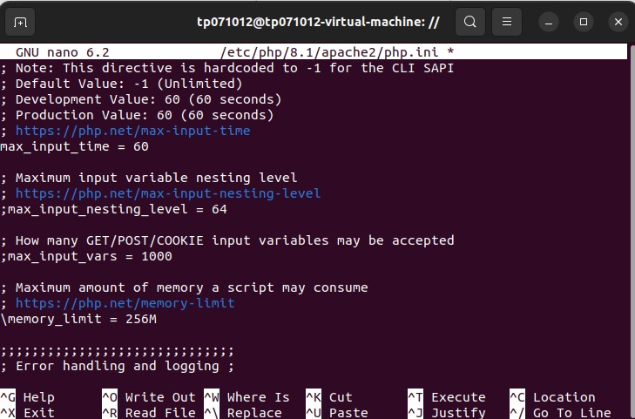

Figure 58

The screenshot displays a terminal script that uses `sudo` to get elevated privileges and `nano`, a command-line text editor, to alter the `php.ini` file for PHP 8.1 on an Apache2 server. This is how the phpldapadmin website is normally modified to increase the RAM limit.

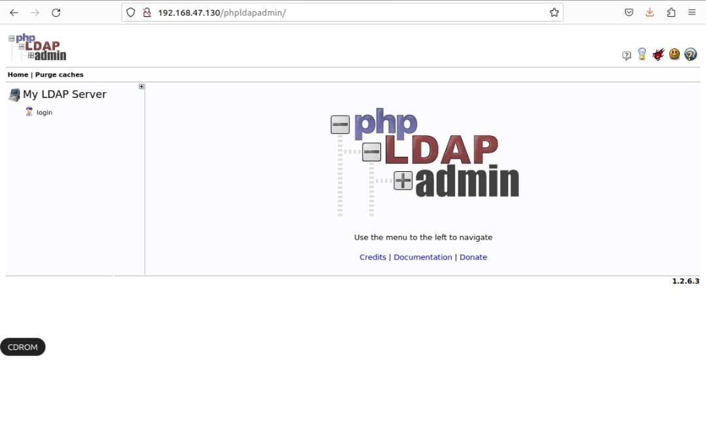

Figure 59

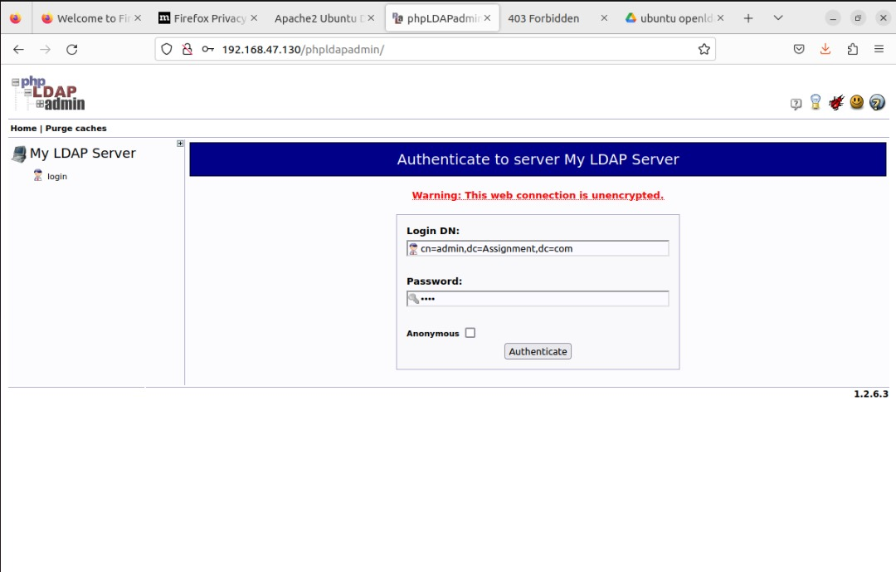

Figure 60

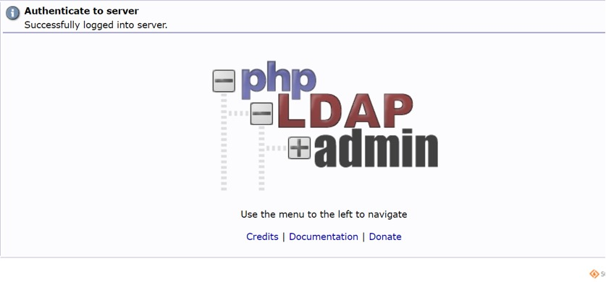

Figure 61

After changing the RAM limit, we are able to visit the phpldapadmin page and log in. The same password that we used to install the open ldap is the login DN, which is (cn-admin,dc=Assignment,dc=com). We can then successfully log in to the admin PHPLDAP when it is finished.

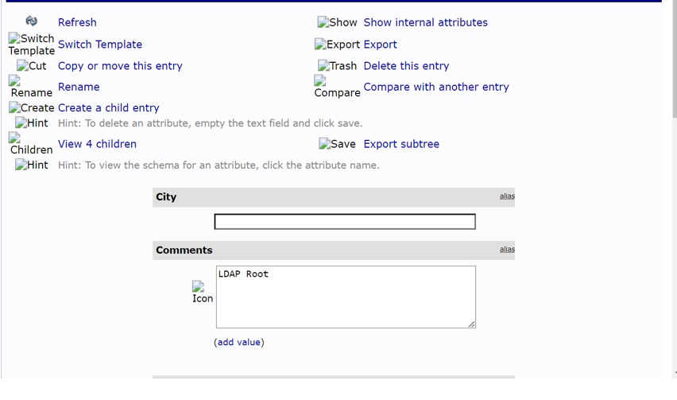

Figure 62

Entering this page gives us complete authority over the LDAP server, allowing us to adjust and administer it as we see fit.

1. **SSL and TLS Implementation.**

Cryptographic techniques like TLS (transport layer security) and SSL (secure sockets layer) enable secure network communication. These protocols provide a secure connection between a client and a server by encrypting data while it’s in transit to stop tampering and listening in. TLS replaced the earlier SSL protocol and provided better security features. To secure email correspondence, web browsing over HTTPS, and other online services, SSL and TLS are both often employed. They are essential in protecting private data, such as login passwords and bank transactions, by maintaining the integrity and confidentiality of data sent between users and servers. (*What Is SSL, TLS and HTTPS? | DigiCert*, 2023)



Figure 63

"sudo nano /etc/dovecot/conf.d/10-ssl-conf” may be used to access the SSL configuration file for Dovecot. Customising SSL settings improves email services security by adding directives here. This process guarantees an encrypted connection between mail clients and the server.

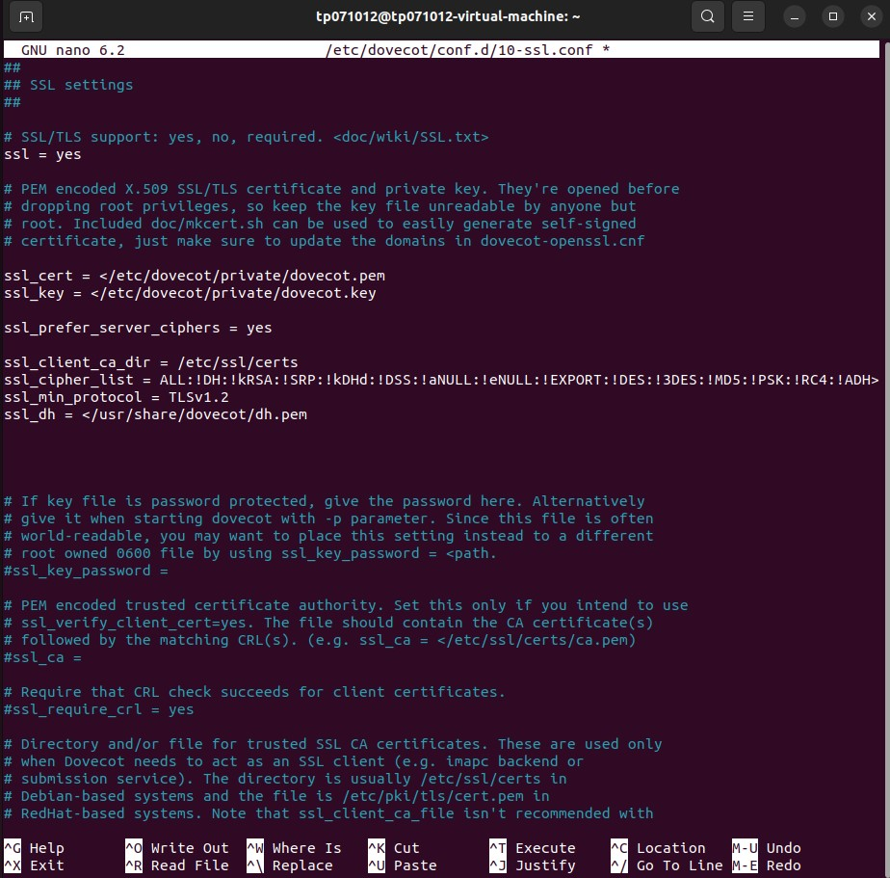

Figure 64

Figure 56 illustrates how the instructions added to “sudo nano /etc/dovecot/conf.d/10-ssl-conf” rganiza Dovecot’s SSL configuration. Enabling SSL communication with the command “ssl = yes” results in encrypted communications. By rganizatio cypher settings, defining certificate pathways, and configuring the minimum protocol to TLSv1.2, security may be rganizat. These arguments establish encryption mechanisms, such as “ssl_cipher_list,” which prioritises strong cyphers for secure email correspondence. This meticulous SSL/TLS configuration corresponds to modern security regulations and best rganizat, enhances Dovecot, and provides a robust and secure framework for managing important email data.

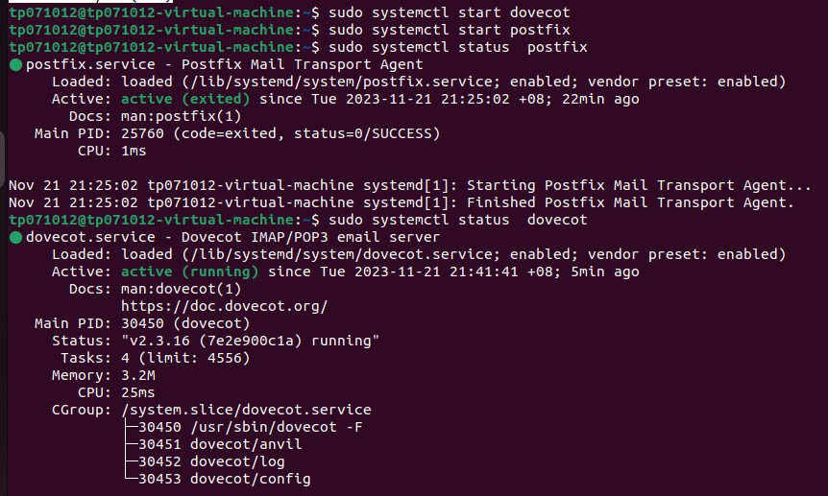

Figure 65

In Snapshot 57, restarting the email server is achieved with “sudo systemctl restart dovecot.” Verifying its status using “sudo systemctl status dovecot” ensures that changes to the SSL configuration take effect, maintaining a secure and operational email server.

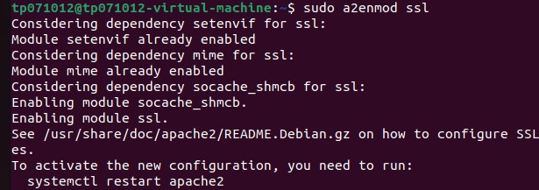

Figure 66

To enable Apache2 to rganiz its SSL module, type “sudo a2enmod ssl”. This command makes it possible to communicate securely via HTTPS by turning on SSL capability. This is a crucial step in configuring Apache2 to send secure data and ensure secure browsing.

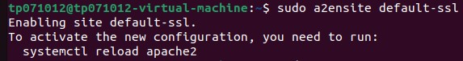

Figure 67

Apache2 may rganiz the default-ssl site configuration by running “sudo a2ensite default-ssl”. This step allows secure HTTPS connections by turning on SSL support for the default site. This command is needed to configure Apache2 for encrypted internet communication.

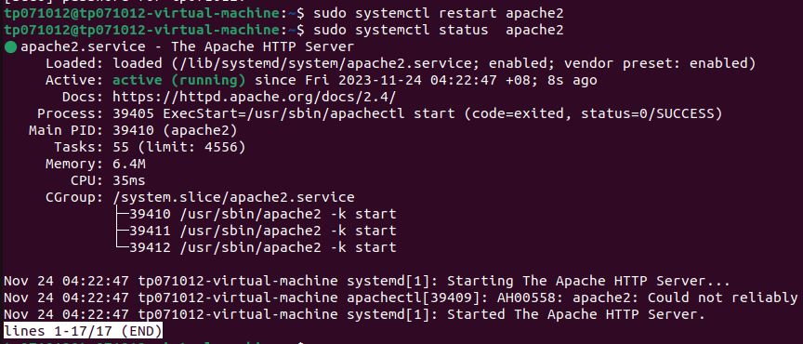

Figure 68

Restarting Apache2 with the command “sudo systemctl restart apache2” applies any configuration modifications you’ve made. You may use “sudo systemctl status apache2” to get the latest recent version of Apache2. This will indicate whether Apache2 is operating correctly or if there are any problems. These commands provide information about the current status of the Apache2 web server and guarantee smooth functioning.

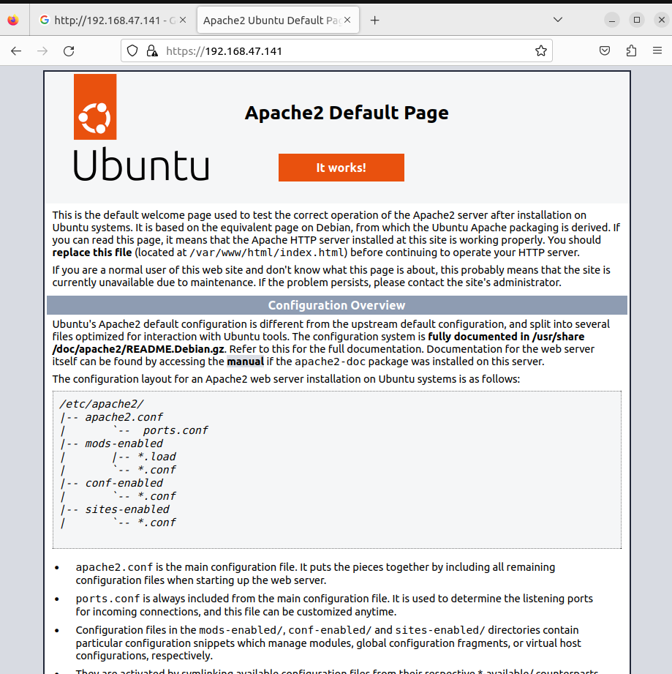

Figure 69

You may browse “https://192.168.47.141” to securely connect to the Apache2 web server over HTTPS. This URL offers customers a safe surfing experience and secure data transit by showing how SSL is implemented.

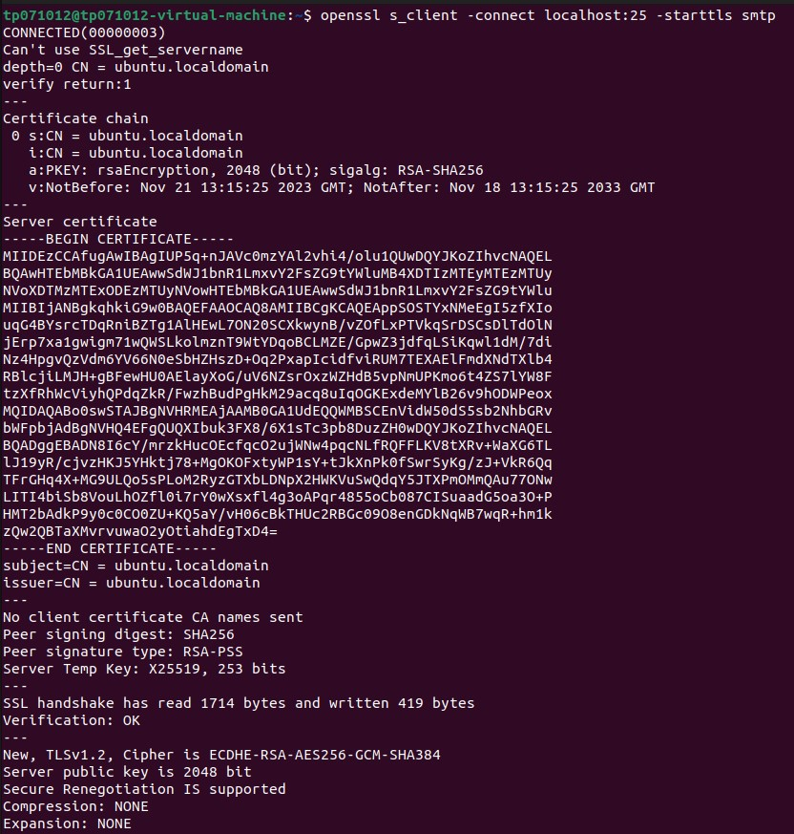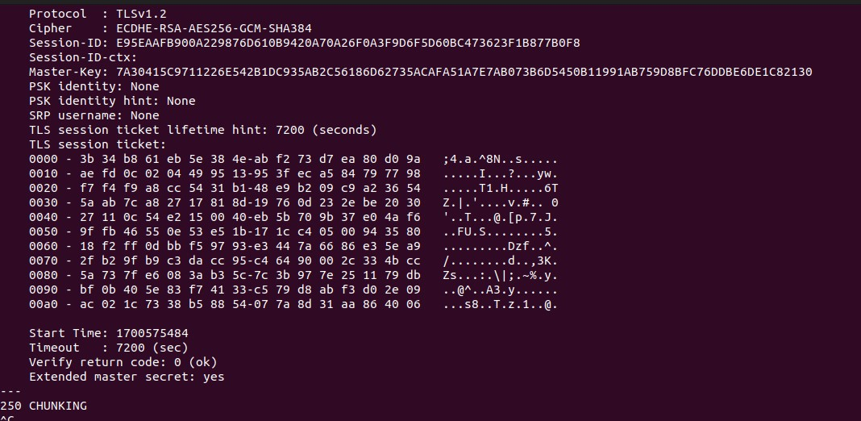

Figure 70

To test secure SMTP communication, run the command “openssl s_client -connect localhost:25 -starttls smtp”. This command creates a secure connection to the localhost SMTP server using the STARTTLS command. Verifying that SSL/TLS encryption is installed successfully for email services is essential to ensuring the secured transport of sensitive data. This diagnostic feature facilitates the evaluation of secure communication protocols by confirming that the email server is configured to manage secure connections—a critical element in maintaining the confidentiality and integrity of email messages.

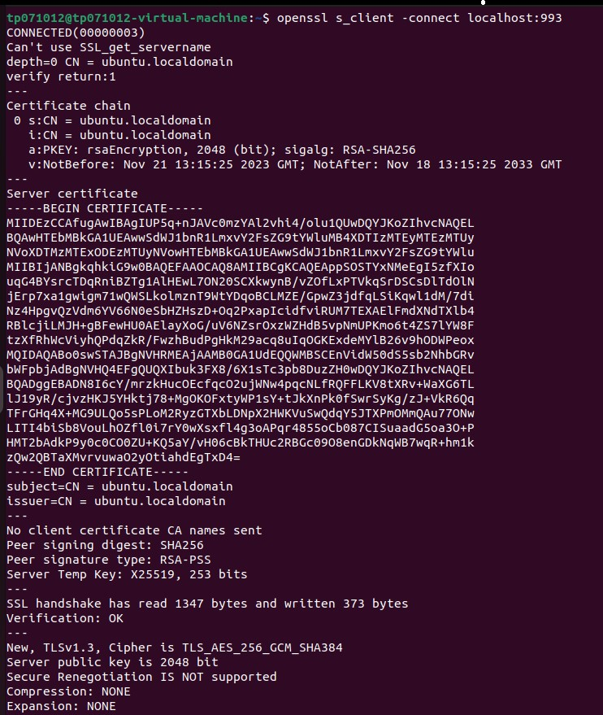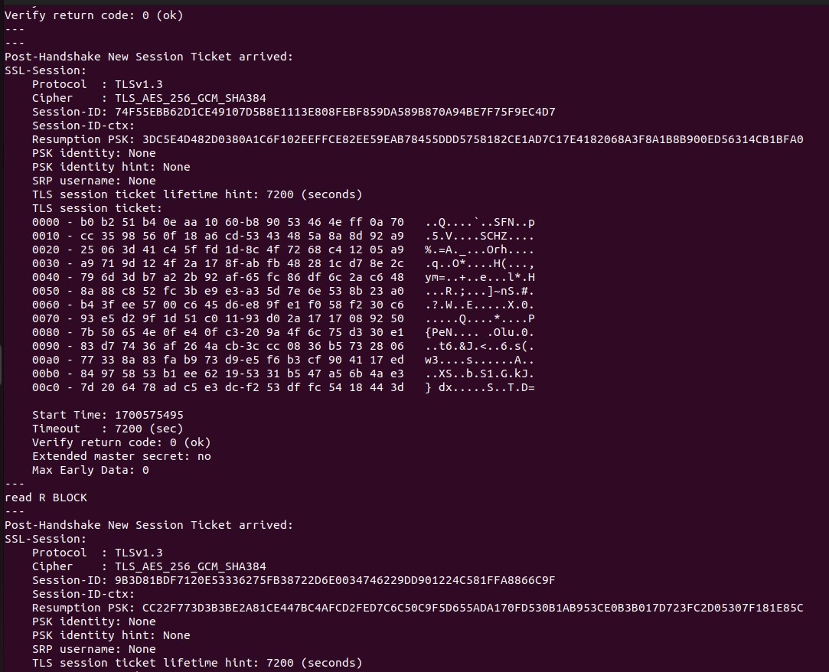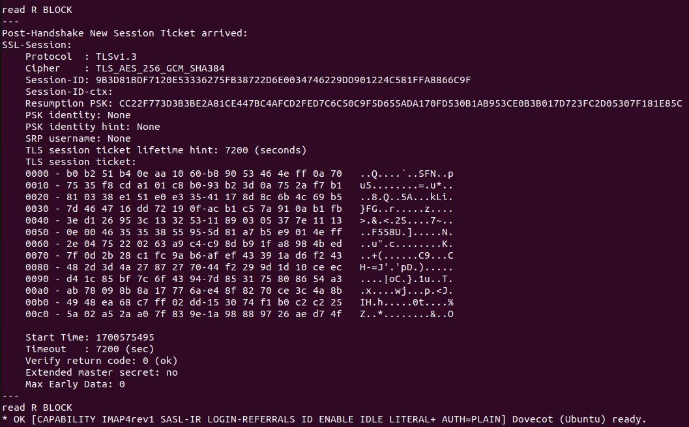

Figure 71

To enable secure IMAP connection, use “openssl s_client -connect localhost:993”. To effectively implement SSL/TLS encryption for email services, this command creates an encrypted connection to the local IMAP server. It verifies that the server is prepared for safe IMAP connections and that it can transfer sensitive data in a secure manner. Evaluating secure communication options is essential to maintaining the privacy and accuracy of email conversation. Because a secure email system depends on the server’s ability to manage reliable and secure IMAP connections, this diagnostic tool is essential.

1. **- Testing The System.**



Figure 72

To start and enable the ISC DHCP server, use the command "sudo systemctl start isc-dhcp-server", verify its status, and ensure dynamic IP configurations are available within the assigned network. And the server is successfully working.



Figure 73

To restart a server and apply configuration changes, use the command "sudo systemctl restart bind9" and check the server's real-time status. This allows administrators to make seamless modifications and address potential issues, ensuring DNS server reliability and responsiveness.



Figure 74

Postfix and Dovecot are simultaneously activated, indicating successful integration within the network. This results in a robust and flexible email system, demonstrating the importance of these components for efficient network administration and exchange.



Figure 75

The system service manager, systemctl, can be utilized to check the status of the slapd service, indicating that it was successfully started or restarted after setup, thereby confirming the LDAP service's operationality and usability.



Figure 76

The Apache2 server is functioning properly, as indicated by the command "sudo systemctl status apache2". These commands ensure smooth operation and provide in formation on the server's current state(active(running)).

1. **- Conclusion.**

To sum up, this assignment helped us better grasp the challenges involved in rganizat Virtual Box to develop a whole Linux-based system. Every stage involved in building a strong network architecture was completed by installing and configuring the necessary services, including LDAP, email, web, DNS, DHCP, and SSL/TLS encryption, as well as by making server configuration changes and guaranteeing smooth functioning. The helpful method highlighted the need of fine-grained rganizationa for small-scale rganizational demands by demonstrating how potent tools like Apache2, Postfix, Dovecot, and BIND could be incorporated. This project showed how to set up a variety of services and highlighted how important it is to get everything just right in order to create a networked, secure system that facilitates cooperation and communication.

1. **References.**

* *Internet Systems Consortium. (2020, June 23). BIND 9. Isc.org. https://www.isc.org/bind/*
* *Gillis, A. S. (2023). DHCP (Dynamic Host Configuration Protocol). Networking; TechTarget. https://www.techtarget.com/searchnetworking/definition/DHCP*
* *Why. (2015, August 24). Why use both Dovecot and Postfix? Super User. https://superuser.com/questions/962074/why-use-both-dovecot-and-postfix*
* *Syed Balkhi. (2013, May 14). What Is Apache? What Is a Web Server? WPBeginner. https://www.wpbeginner.com/glossary/apache/*
* *Okta, Inc. (2023). Okta.com. https://www.okta.com/identity-101/what-is-ldap/*
* *What is SSL, TLS and HTTPS? | DigiCert. (2023, June 7). Digicert.com.* [*https://www.digicert.com/what-is-ssl-tls-and-https*](https://www.digicert.com/what-is-ssl-tls-and-https)
* Noviantika G. (2022, April). *What Is Ubuntu? A Quick Beginner’s Guide*. Hostinger Tutorials. https://www.hostinger.my/tutorials/what-is-ubuntu?ppc_campaign=google_search_generic_hosting_all&bidkw=defaultkeyword&lo=9066360&gad_source=1&gclid=Cj0KCQiA7OqrBhD9ARIsAK3UXh1m1g_3jgTIPfmoQP4cPLfM25HPJNaLGp04E9seDX_TYLKXEmgkm58aApkbEALw_wcB
* Bastiaansen, R., & Lanigan, R. (2019). *VMware*. SearchVMware; TechTarget. <https://www.techtarget.com/searchvmware/definition/VMware>
* *Postfix Basic Configuration*. (2023). Postfix.org. https://www.postfix.org/BASIC_CONFIGURATION_README.html
* *Configuration - LdapRecord*. (2023). Ldaprecord.com. https://ldaprecord.com/docs/laravel/v2/configuration/
* *Install and configure Dovecot | Ubuntu*. (2023). Ubuntu. https://ubuntu.com/server/docs/mail-dovecot
* Both, D. (2021). *How to configure an Apache web server*. Opensource.com. https://opensource.com/article/18/2/apache-web-server-configuration
* *Domain Name Service (DNS) | Ubuntu*. (2023). Ubuntu. https://ubuntu.com/server/docs/service-domain-name-service-dns
* ‌